20CYS403 – Web Application Security
PHP Programming Lab

Ponvedica M S
CB.SC.U4CYS23034

Q1. hello.html vs hello.php
since, html is static – it shows both the html and the php code in the website whereas php is dynamic so, it shows only its own not the html.
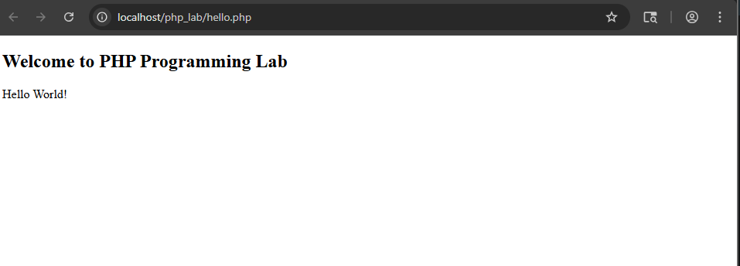
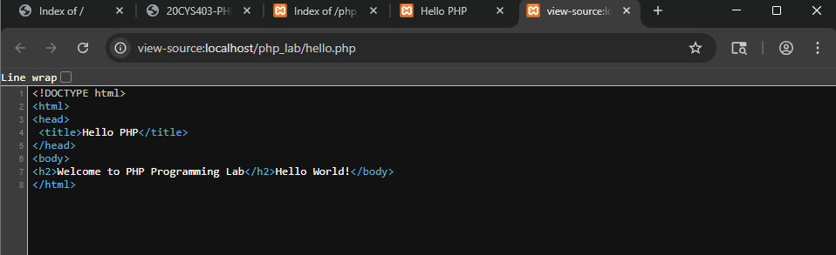
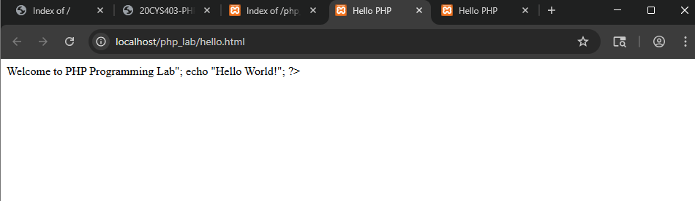
Q2. Variables
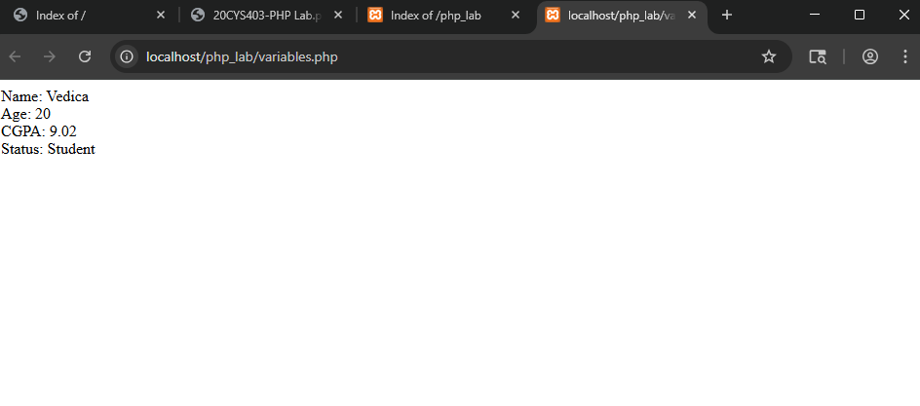
Q3. Operators
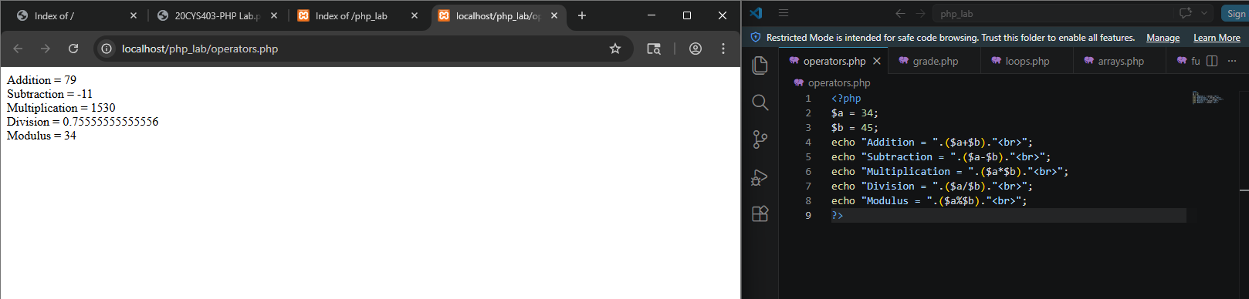

Q4. Conditional statements
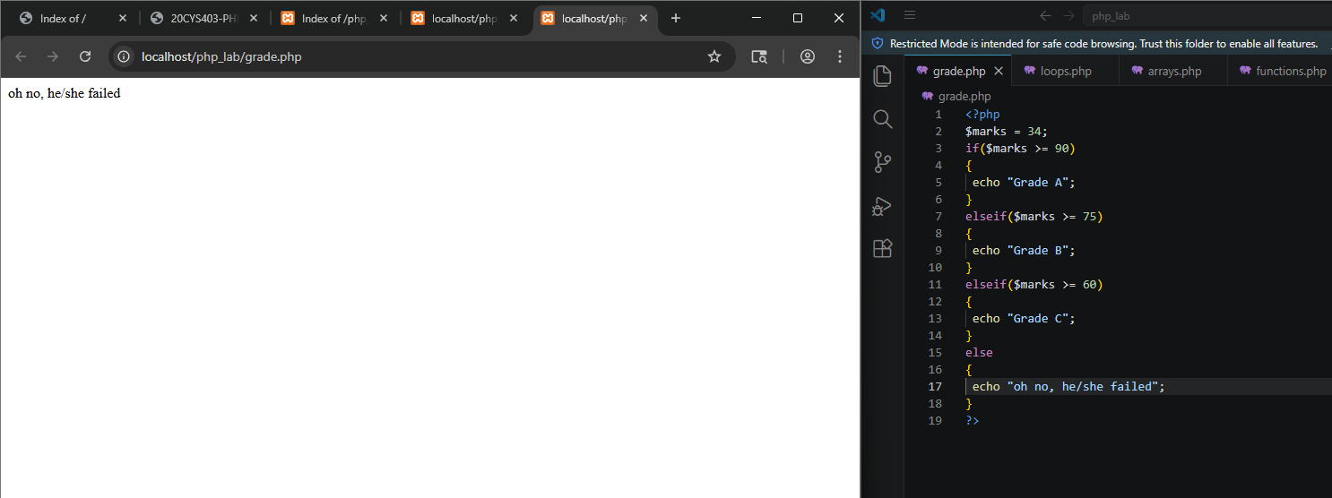

Q5. Loops
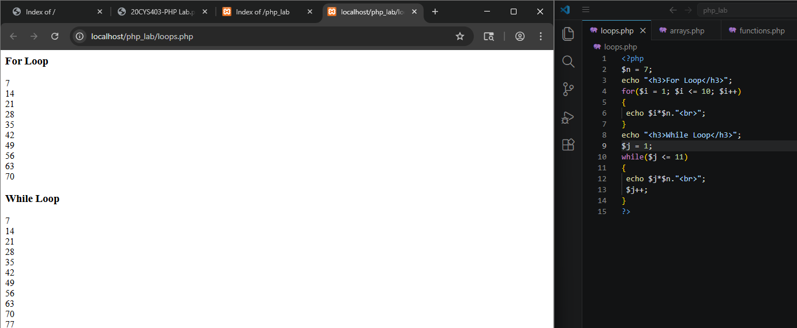

Q6. Arrays
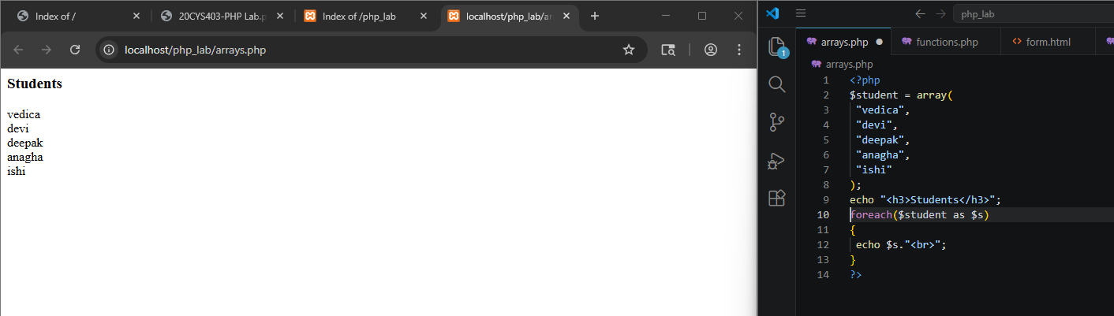
Q7. Cookies
Before changing the expiry time – we can able to see the cookies in the dev tools as vedica
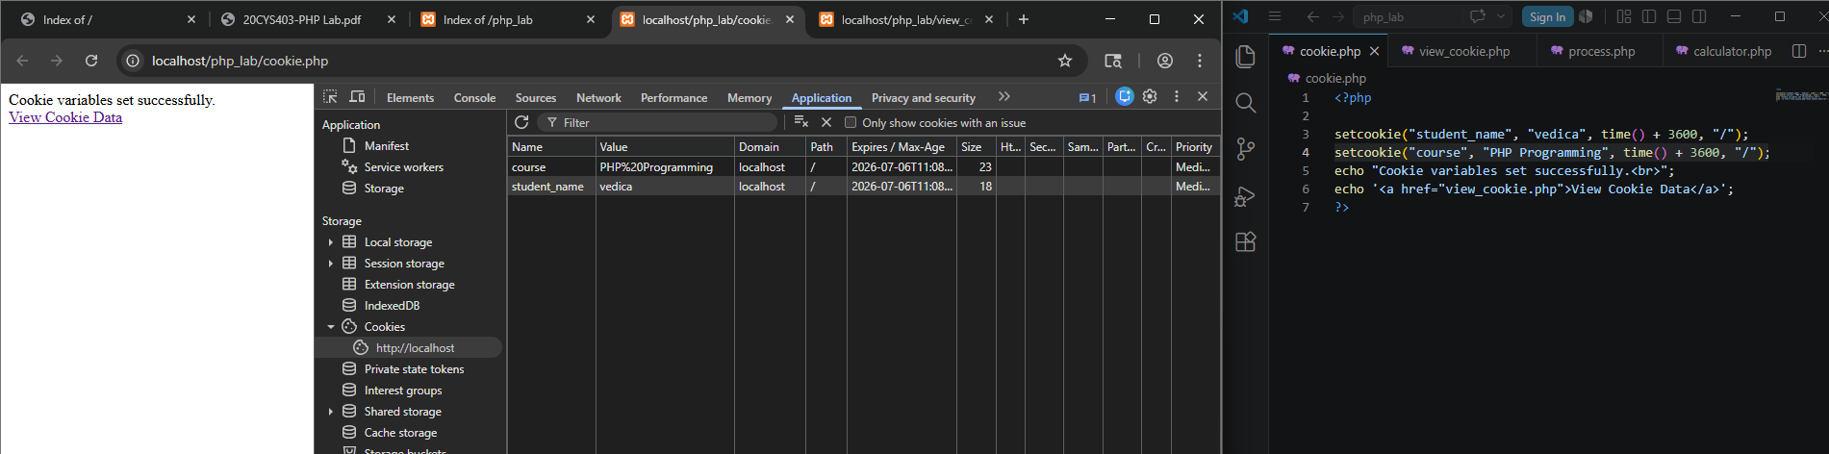

After changing the expiry time – the past viewed cookies are deleted as we go in past.
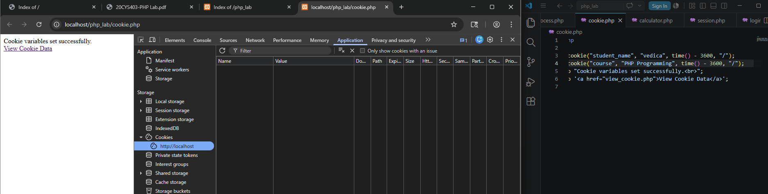
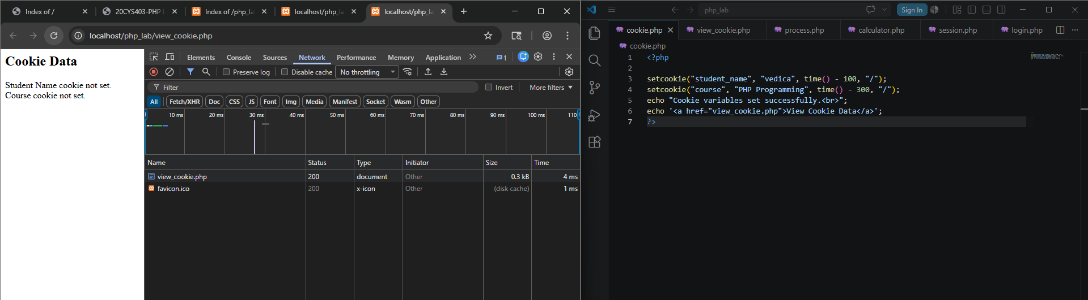

Q8. User Defined Functions
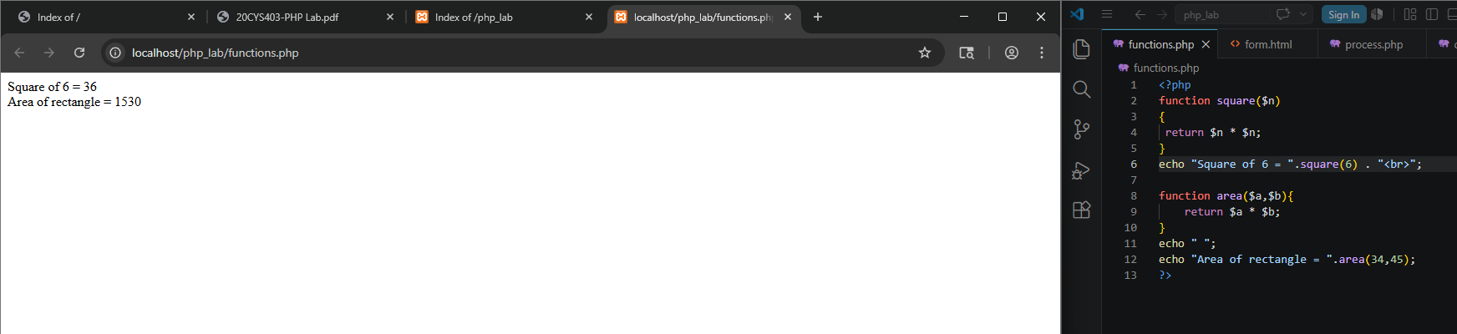

Q9. Form.html
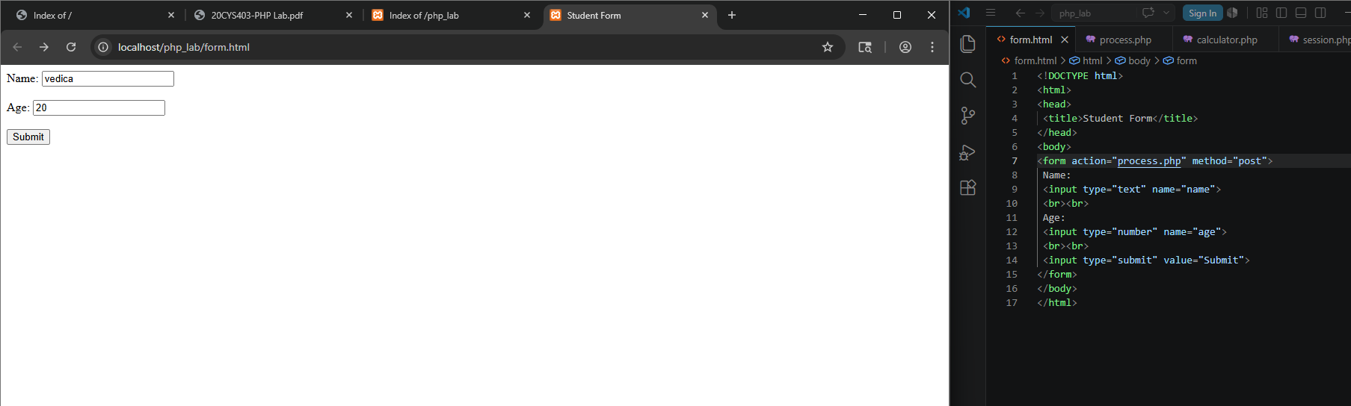
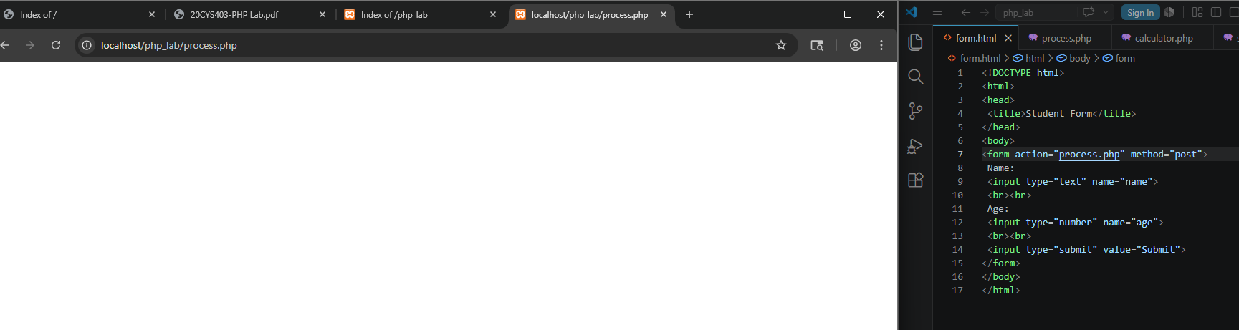
Q10. Form Processing
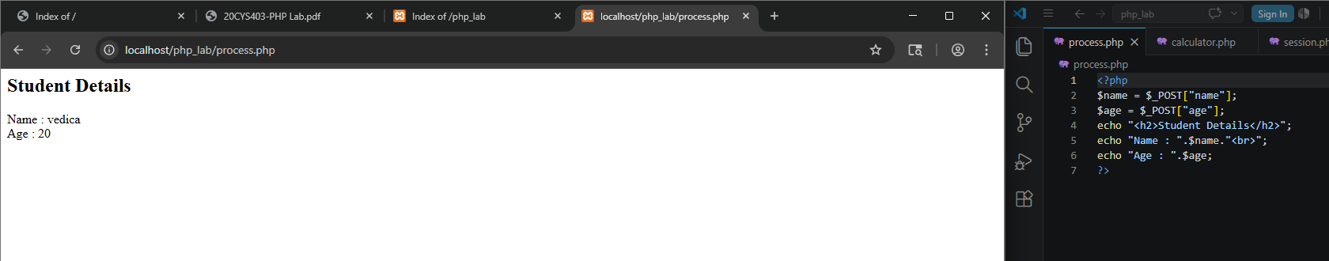
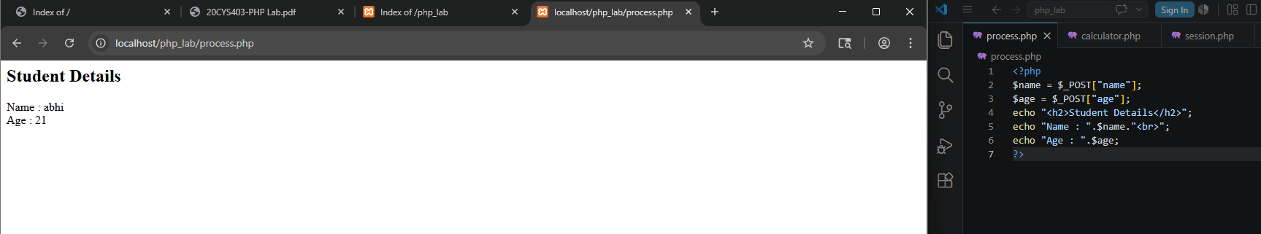

Q11. Simple Calculator
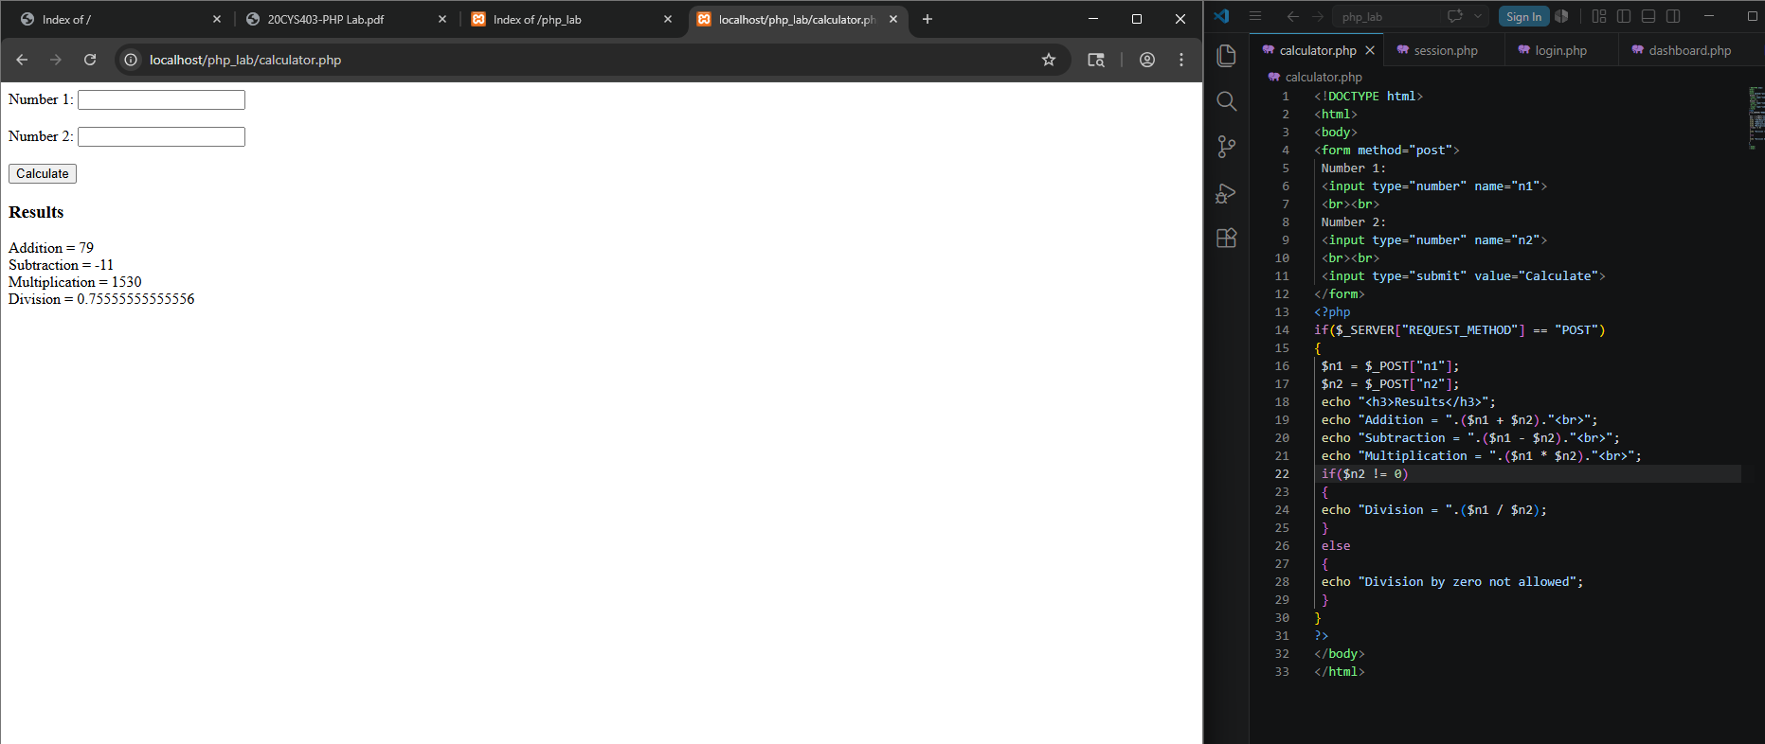

Q12. Basic Form Validation
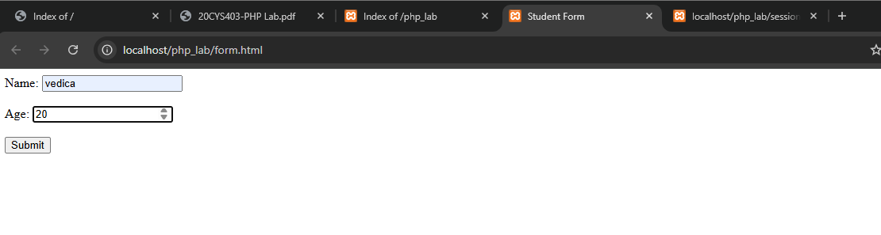
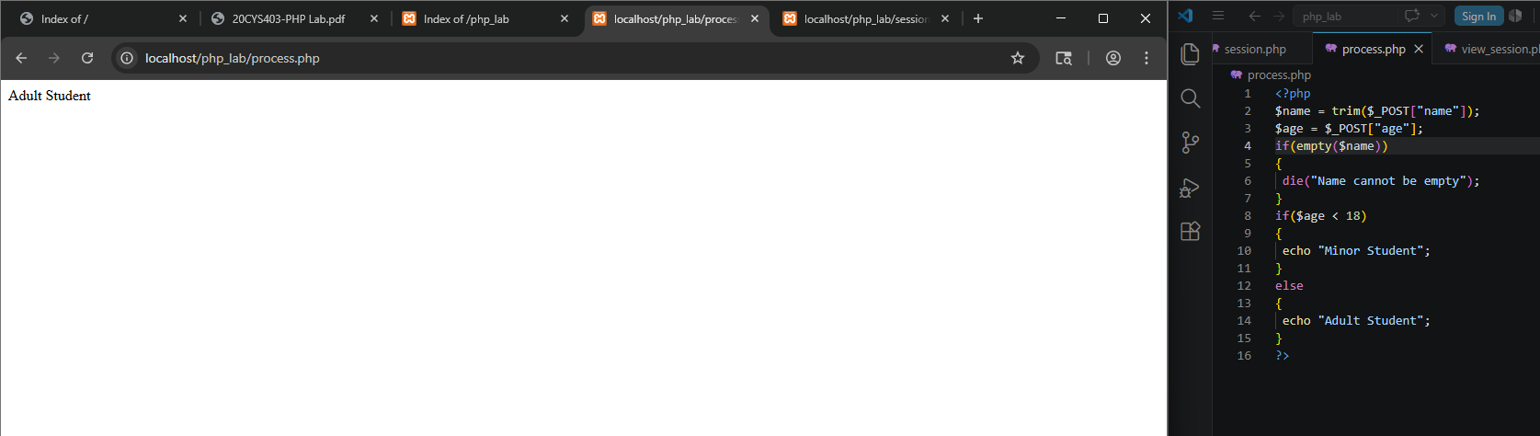
Why is server-side validation important even when client-side validation is used?
Client side validation can be easily bypassed by disabling JS or modifying browser code, whereas Server side validation is important to block malicious attacks and ensure that invalid data never reaches DB.
Q13. Session Handling Basics
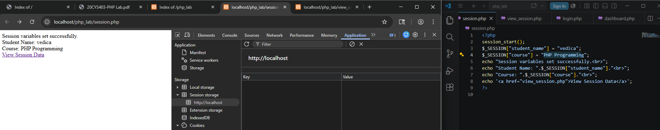
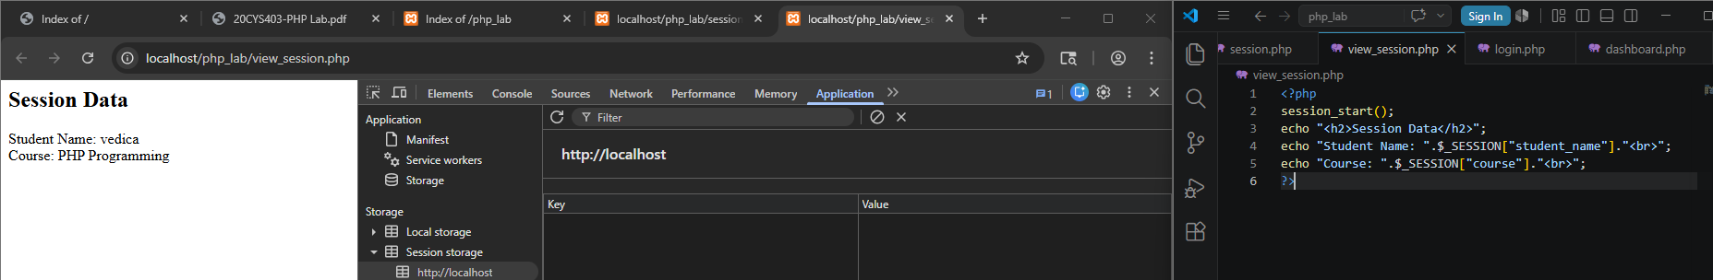
This is the session of ‘vedica’ and we can’t view the session from a client side, session stores in server side. So we can’t able to see the session over here.

Q14. Session-Based Login and Logout
First, login after changing the username and the password to ‘vedica’ and ‘123’ respectively. We are logging in successfully.
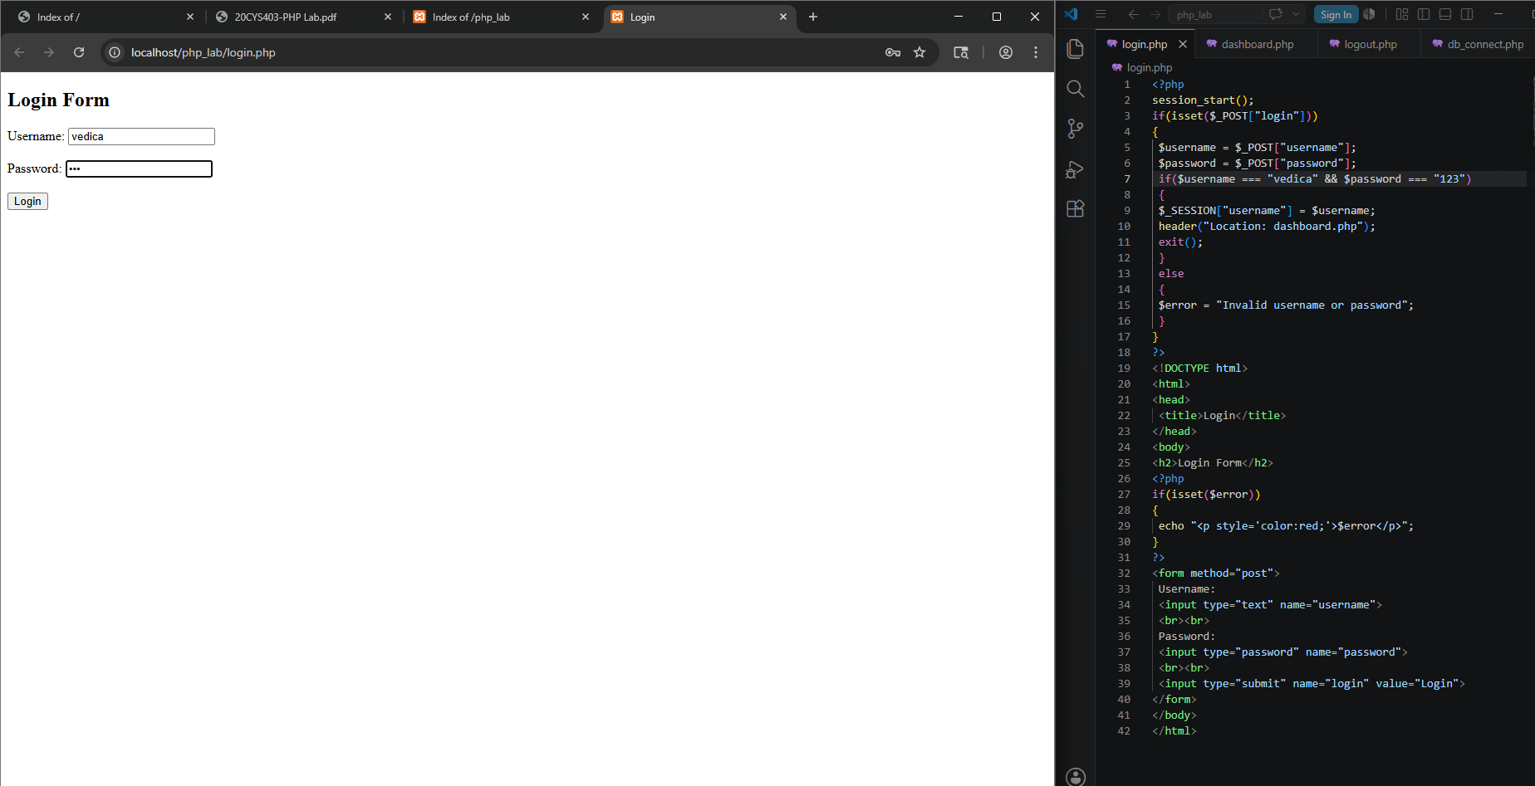
Now, if we try to login with the previous login credentials – it goes to the invalid and won’t get to next page.
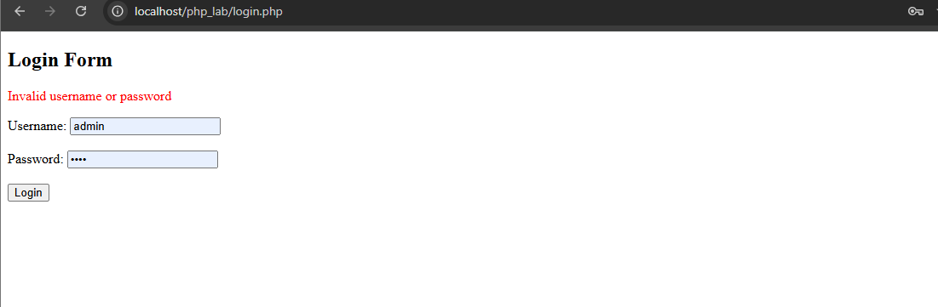
Once, the login is successful – it shows welcome ‘username(vedica)’
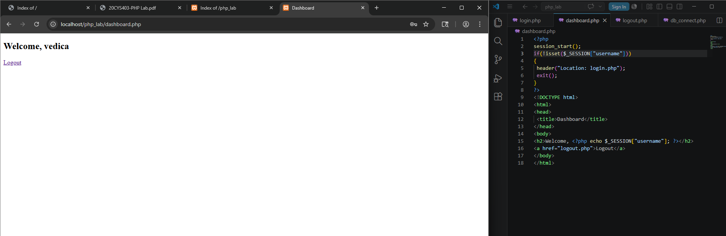

Once, we click the logout – it goes back to the login page again.
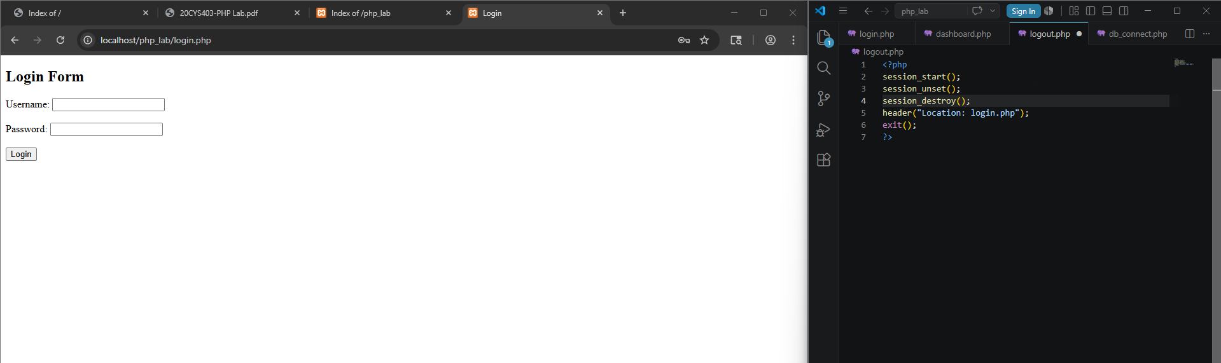
Q15. Connecting PHP to MySQL
Go to -> http://localhost/phpmyadmin -> typed the command below
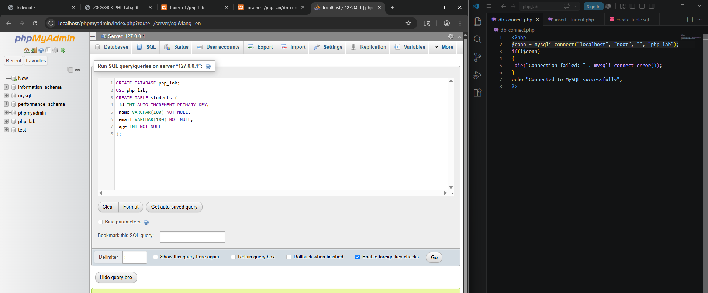
Then click go -> DB is created.
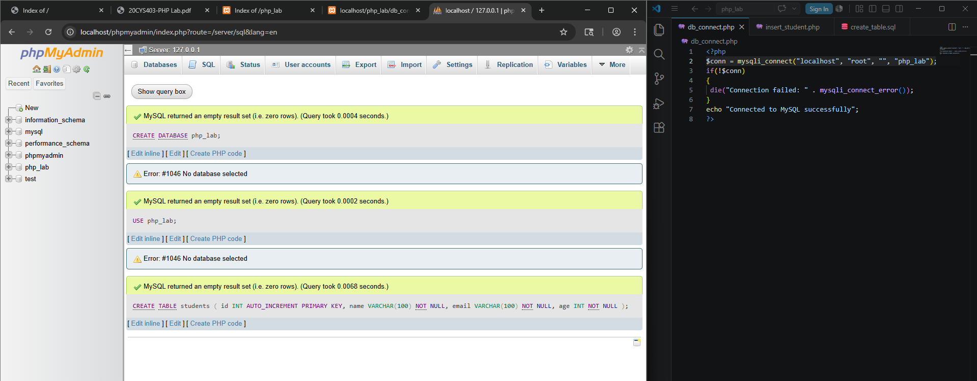

db_connect.php -> has successfully connected to the DB
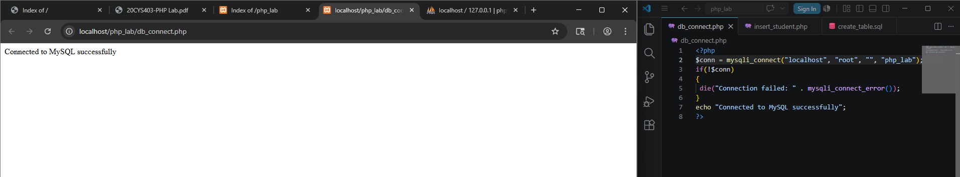

Q16. Connecting PHP to MySQL
